CPSY 200

SIM TUTORIAL ASSIGNMENT #2

Assignment:

First, create a directory called titled ‘yourlastname’_sim-tutorial2’. When you start you project, save your SIM project to this directory. Create an MS Word file in this directory that will contain your exported diagrams. Follow the guidelines to create the following diagrams.

1. **SIM Tutorial: Create a Use Case Diagram in a new project.**

* Start SIM.
* Start the “Standard Edition” (free for personal use including educational) and confirm that this is for personal use.
* Create a project:
  + Create New Project button near bottom of screen; Project Properties will be displayed.
  + Name project: Project1
  + Type set: Select **Process** from the menu bar, then choose **Types**. Select *Java* and unselect *UML*.
  + Make sure to save the project. Under File, choose Save As and the select Save To Local Folder to directory of your choice.
* If you missed setting the Type set above it can be changed as follows: From the Menu bar select **Process 🡪 Types**; select Java to add Java types to legal data types, and unselect UML.

Use Case Diagram

* Select Use Case Diagram under Add New Diagram at right side of screen ( or + sign on project tabs) 🡪.
* Name the diagram (double click the window tab) something relevant to the system.
  + e.g., If the whole system is named “Da Project System”, name the use case diagram “Da Project Use Case Diagram” (after all, the use case diagram should represent the whole system).
* Start the diagram by placing and naming a system boundary and the actors.
  + Place system boundary by selecting system boundary from the left menu and drag onto the diagram frame and name it
  + Click on Actor in the left menu and drag onto the diagram frame to the left of the system boundary (i.e. outside the boundary) and name the actor Campaign Manager.
* Add a use case element to the Use Case Diagram called “Assign staff to work on campaign”
  + Elements may need to be resized to prevent word wrapping.
  + Try to keep the actual icons the same size.
* To add an association between elements, drag the association and place it over one of the elements.
* Draw the following diagram:

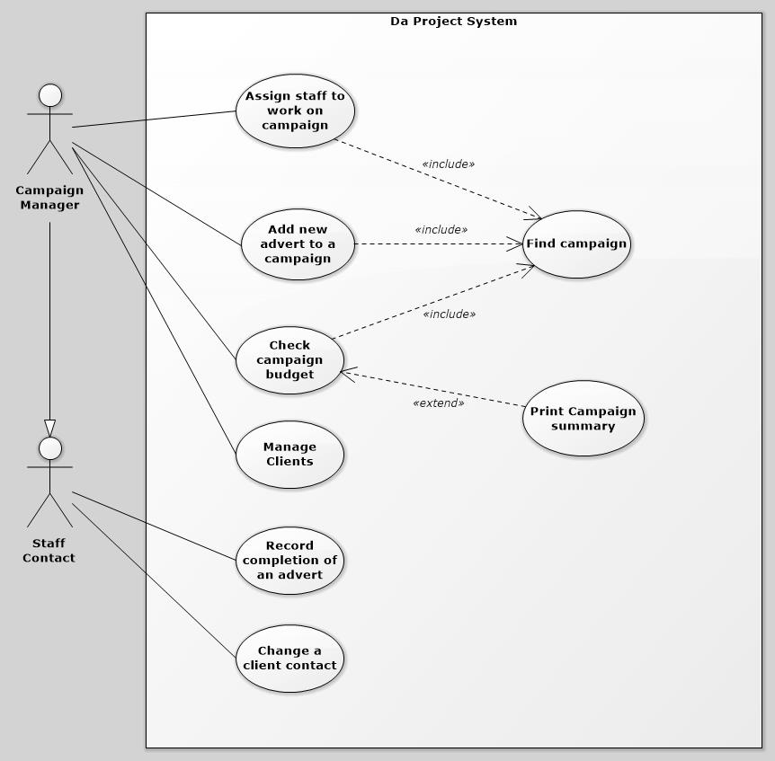

* The arrow between the Campaign Manager and the Staff Contact is a generalization (i.e. inheritance which means the Manager can do anything the Staff Contact can do plus “Record completion of an advert and Change a client contact”).
* If you want to put an element “behind” another, you can select the element then use the Send to Back Button on the Home toolbar (e.g., if you want to add a system boundary after you’ve already drawn some use cases).

Generally, avoid the Drawing palette (lower left of SIM menu). Standard UML tools menu should include all of the symbols required the purposes of this course.

SIM Tutorial: Build an analysis-level class diagram.

Next, build an analysis level class diagram and associate it with the use case diagram previously created.

* Open the project that contains the use case diagram that includes “Add a new advert to a campaign” (i.e. Project1)
* Build a class diagram that includes the following classes of objects shown in the class diagram below.
  + Again, name the diagram something relevant to the system (e.g., “Da Project Class Diagram”).
  + Select a class element from the left menu and drag it on to the diagram frame.
  + Name the class Client and then right click on the class diagram and choose element properties to add details to the class element. (The “entity “ descriptor can be added as a custom stereotype.)
  + Add further class details using the Attributes and Operations tabs.

SIM Tutorial: Build an analysis-level sequence diagram.

* Right click the “Add a new advert to a campaign” use case and Add New Diagram.
  + Add a new sequence diagram named: Add New Advert.
  + Note that a new symbol is added to the “Add a new advert to a campaign” use case in the use case diagram.
    - This is a link from that use case to the sequence diagram.
    - The link is not included when the diagram is exported.
  + Select the actor Campaign Manager from the right side menu list for the current project and drag the actor on the diagram frame.
* Add a lifeline for an object of type Client.
  + Drag the Client class from the Project View and place it.
    - Alternatively, add a lifeline and choose the lifeline Properties 🡪 Classifier More button (…) to select the class desired.
  + Leave the name blank (if a default name appears, double click the default name and erase it).
    - If you leave the lifeline name blank, this is displayed as an anonymous object of the class entered.
  + Note that you have now made logical connections between an object in this diagram, and a class in another diagram. This ensures **model consistency**.
  + Now, to get a method call to happen between the Campaign Manager and the Client object you need to select the type of message i.e. call message and then, on the diagram frame select the actor and drag the call to the Client and choose the method call from the list of existing methods in the Client object.
* Add Campaign and Advert objects to diagram as shown
  + Now add a call message element for getClientCampaigns()
  + Add a loop fragment to the diagram as shown in the sequence diagram.
  + To add the square bracket details right click on loop element, element properties and select Fragment tab. Now, under the fragment tab add an interaction operands and fill in the guard condition as “For all client’s campaigns”.

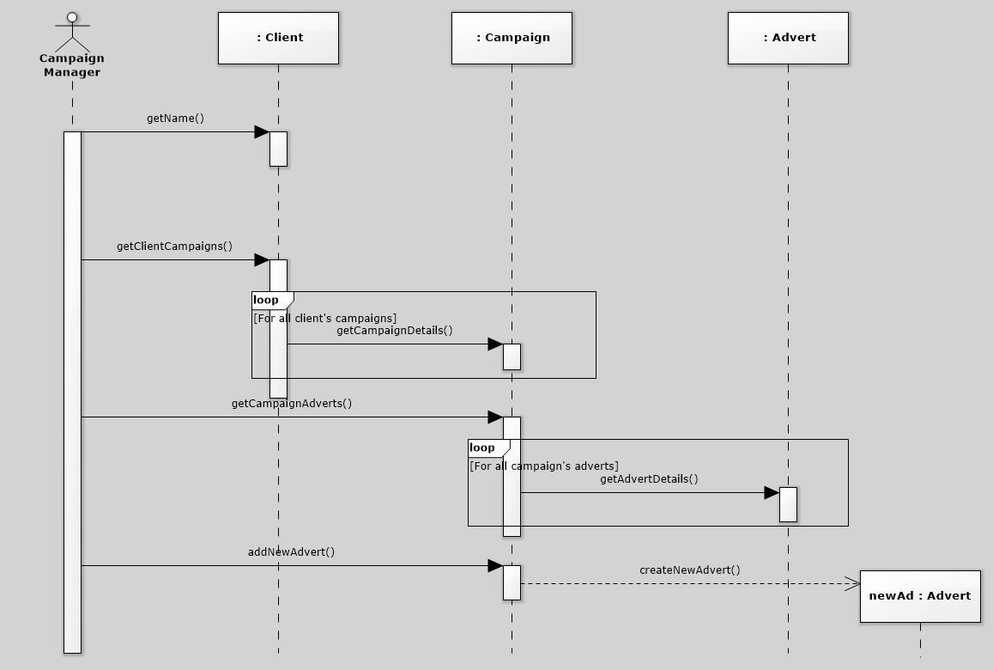

SIM Tutorial: Build a State Machine Diagram for a Campaign.

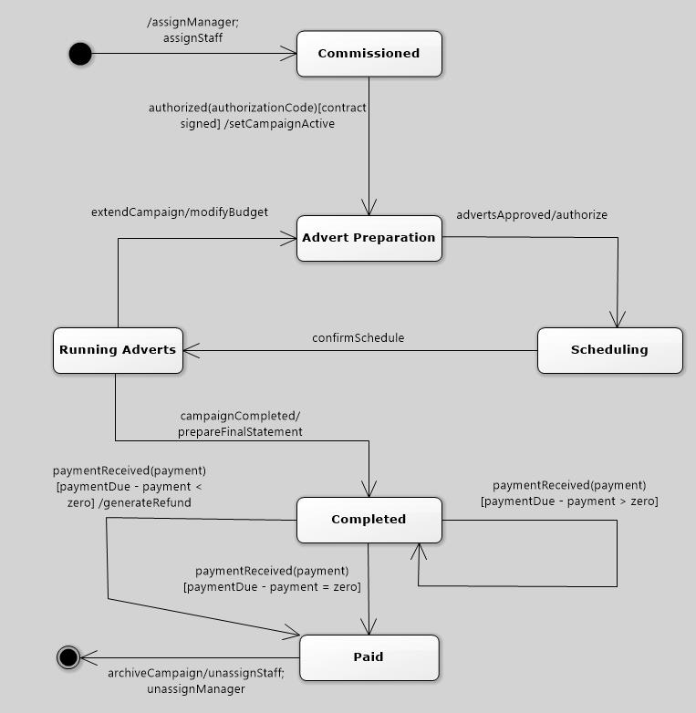

* Right click the Campaign class and add a new State Machine diagram named Campaign Lifecycle.
* Drag and place an Initial State icon, leaving the name blank.
* Drag and place state icons for states: Commissioned, Advert Preparation, Running Adverts, Scheduling, Completed and Paid.
* Drag and place a final state icon, leaving the name blank.
* Select the transition icon, and click and drag from the initial state to the Commissioned state, leaving the name blank.
  + Open the relationship properties and find the Transition tab 🡪 Behavior Expression field.
  + Enter assignManager(); assignStaff()
* Add a transition from the Commissioned state to the Advert Preparation state, with Trigger: authorized(authorizationCode), Guard Condition: contract signed and Behavior Expression: setCampaignActive()
* Add all additional transitions between the states.
  + Pay particular attention to what is a trigger, guard condition or behaviour expression.
  + The messages are simply labels because this version of SIM does not support selection of an object operation as the message classifier.
* Add a transition between the Paid and the Final states, with the Trigger: archiveCampaign and Behavior Expression: unassignStaff;unassignManager.
* Move states and transition labels around until the diagram looks neat.
  + Occasionally, it is useful to align a group of elements: select two or more elements, then choose Arrange 🡪 Alignment 🡪 Center Horizontally or Center Vertically from the toolbar.

SIM Tutorial: Build a design-level ‘Manage Client’ sequence diagram.

* Open the project that contains the use case diagram that includes “Manage clients”.
* Right click the Manage clients use case and Add New Diagram.
  + Add a new sequence diagram named: Manage clients.

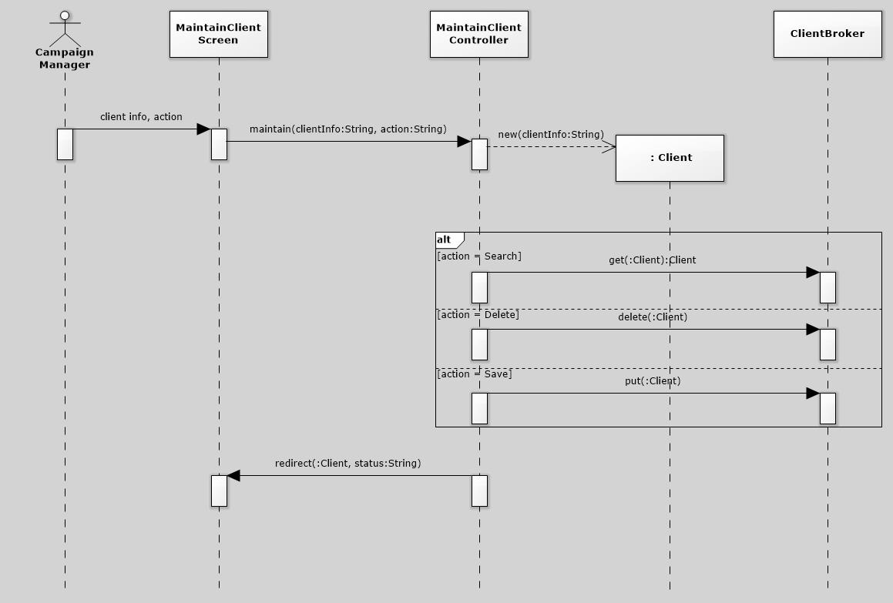

* Drag the Campaign Manager actor from the Project View, and place it on the diagram.
* Add a lifeline for an object of type MaintainClientScreen. Leave the name blank, and choose Properties 🡪 Lifeline 🡪 Classifier, enter MaintainClientScreen.
  + The class does not yet exist in a class diagram, so the name typed into the Classifier text field is ONLY a label. Any class created later with this name is NOT LOGICALLY CONNECTED to this lifeline, so your project WOULD NOT be consistent.
    - Therefore, it is important to create class diagrams that contain all classes that will appear in a sequence diagram BEFORE creating the sequence diagram (even though this was not done for this tutorial).
* Add additional lifelines for MaintainClientController and ClientBroker.
* Add messages (“Call Action”, “Create Action”, etc.) as needed.
  + The messages are simply labels because not all classes and methods exist in previous diagrams.
* Add a conditional (“Alt Fragment”) construct (Search, Delete, Save).
  + Note: to have the fragments layer properly enter in reverse order from above line.

SIM Tutorial: Use SIM to build the following activity diagram:

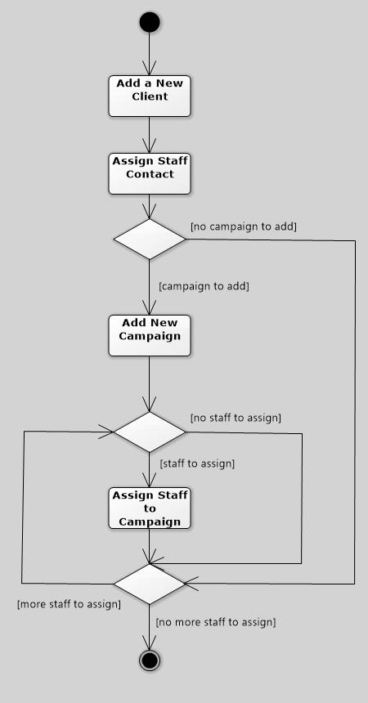

* Start SIM.
* Create a new project:
  + Create New Project button near bottom of screen; Project Properties will be displayed.
  + Name project: Project2
* Add an activity diagram from the list on the right side of the Properties screen.
  + The Activity Diagram drawing screen will be displayed.
  + Name the activity diagram “AddNewClientActivityDiagram”
  + Drag and place an Initial Node icon, leaving the name blank.
  + Add a new activity named “Add a New Client.
    - Find the activity icon in the tool palette on the left side of the Activity Diagram screen and drag it to the diagram frame.
  + Add additional activities as needed according to the above diagram.
  + Join the initial node to the first activity clicking on a control flow element then by clicking on the initial node and dragging down to the first activity.
  + Add all other activity nodes and three decision elements to the diagram.
  + Add all flow control elements between the activities and decisions.
    - Any control flow arrows that require a guard condition add this by clicking on the arrow and right, open Relationship Properties 🡪 Control Flow tab 🡪 fill in guard text.
  + Complete diagram.
* Save the project and exit.

SIM Tutorial: Copy Activity Diagram from PROJECT2 to PROJECT1

* Open PROJECT1
* Project 🡪 Add Existing Diagram
  + Select and open PROJECT2
  + Select checkbox of diagram to add
  + OK
  + Voila!

SUBMISSION:

You will submit both your Software Ideas Modeler (SIM) project file (.simp file) and a MS Word or PDF document. Export the diagrams from SIM into your document. Your document will contain the following:

* Your name and student ID.
* Each diagram on a separate sheet.

Please note: It is recommended that when working with diagrams to convert the document to a PDF format.

When completed, please ‘zip’ your project folder and submit it to Brightspace under Assignments/SIM Tutorial 2